## **Interiors and Your Architect’s Scientific Question**

### Overview

You will begin working on your architect’s CNfA (Cognitive Neuroscience for Architecture) question. Your goal is to:

1. Create a slides presentation.
   * Choose your primary question - rewrite it in a more complete manner (along with more complete versions of the other 4 questions that you are **not** going to work on), according to the chatgpt prompt provided.
   * For your chosen question add an explanation of the cognitive, architectural and neuro terms mentioned in your own rewritten question.
2. Collect **25 images of interiors** linked to the scientific question you have chosen give your architect's 5 questions. Label each and mention in a sentence or two why you think it relates to your question it illustrates.
3. Provide a visual interpretation of the hypothesis that shows what would confirm and contradict it. This is a 2 x 2 matrix.
   * Annotate the images so we know why you think each explains the cell in the 2 x2 it is supposed to illustrate.

NOTE: Most architects’ scientific questions focus on **interior** spaces, so you will concentrate on images that show the inside of the buildings.

## **Deliverables: Details**

## 

**1. Slides Presentation**

* Title the file: **“[Your Architect]: CNfA Question.”**
* Within these slides, **identify the main question** you want to explore, based on the “five questions per architect” in Book Two.
  + Advice: Consult the various appendices in Book Two for help in understanding the question and finding ways it might be formulated. Look at Book One (and any other available books/files) for variations or related aspects of that question. Book One is on topics in CNfA and contains many many questions. [Use this link to review Book One](https://docs.google.com/document/d/1gTIC9zuaDAdQFjUxw6ZO5f1ThnCqxwQf/edit?usp=sharing&ouid=102761661805155810451&rtpof=true&sd=true)
  + [Links to an external site.](https://docs.google.com/document/d/1gTIC9zuaDAdQFjUxw6ZO5f1ThnCqxwQf/edit?usp=sharing&ouid=102761661805155810451&rtpof=true&sd=true)
  + .
  + Give ChatGPT your question in its concise, expanded and deep forms and ask it to restate the hypothesis in a manner that makes sense to modern cognitive and neuroscientists.
    - See our prompt below for one way to pose that question. See Appendix 4 below for an Example of how the question in Book Two (in its various formulations) can be improved and made more comprehensible.
* Also include in your question statement a brief description of the key cognitive-neuroscientific and architectural concepts. See example in Appendix 3 below showing a question rewrite with explanations of key cognitive, architectural and neural concepts or phrases used in your answer. [This requirement was here before but most people failed to notice it.}
* In addition to the one question you choose to work on this quarter also ask Chat to rewrite the other 4 questions, so Book Two will be more articulate. [This requirement was here before but most people failed to notice it.}
* Include these revised questions in both your slides presentation and your written document.
* DELIVERABLE ONE: Checklist:  
  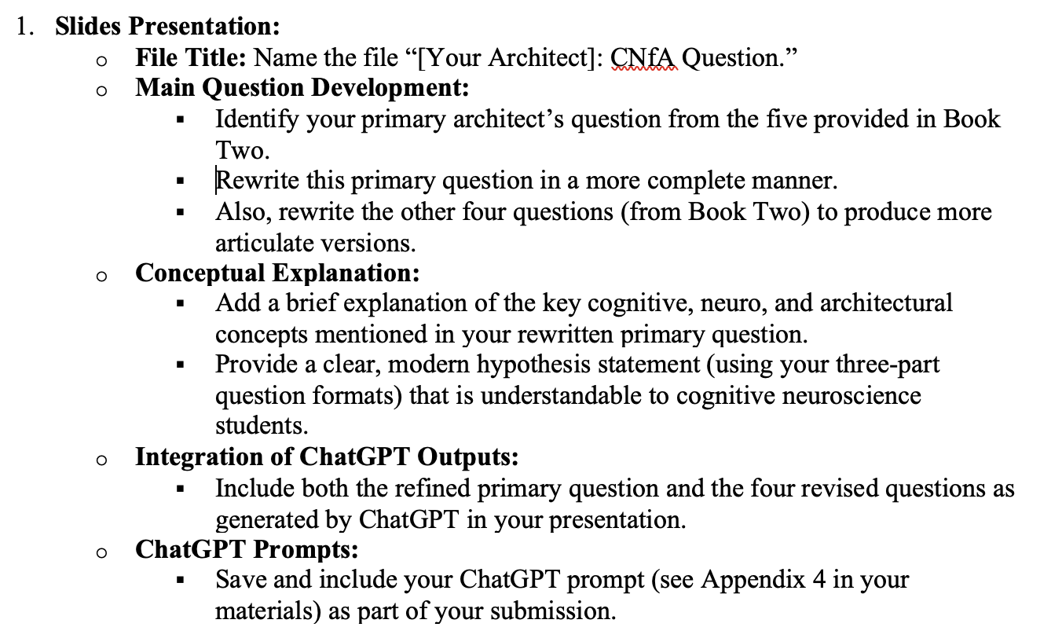

### **2. Collecting 25 Interior Images**

### 

* Gather **25 images** of interiors designed by your architect.
* Explain whether the image is linked to your main question. If it is explain how. Minimally 10 of the 25 should be relevant to the question and the others relevant to at least one of the other questions. .
* **Tip**: Finding interior shots can be challenging. Be very specific in your searches. All images must meet the following guidelines  
  (**see appendix 2**).
* Categorize these images into **5 groups** (with 5 images in each group, for a total of 25):

| **1. Core Functional Spaces** | 5 images |
| --- | --- |
| **2. Programmatic and Specialized Spaces** | 5 images |
| 3. **Residential and Leisure Spaces** | 5 images |
| 4. **Supporting and Technical Spaces** | 5 images |
| **5. Highly Specialized Spaces** | 5 images |

**Example Google Images Query** (if your architect is Zaha Hadid):

"interiors of Zaha Hadid buildings: programmatic spaces"

**HINT**: If you dislike the images you find under a general category, try searching by subcategory. See [Appendix 1.](https://docs.google.com/document/d/1_MG76oF8fBSst7cAyi-MD0wU7_iiFLlS-tRPK9_P7dM/edit?tab=t.m380ovlxaawj#heading=h.x2wgrj6ulwwt)

[Links to an external site.](https://docs.google.com/document/d/1_MG76oF8fBSst7cAyi-MD0wU7_iiFLlS-tRPK9_P7dM/edit?tab=t.m380ovlxaawj#heading=h.x2wgrj6ulwwt)

For instance:

"interiors of Zaha Hadid buildings: workspace areas (e.g., offices, meeting rooms)"

Deliverable Two Checklist

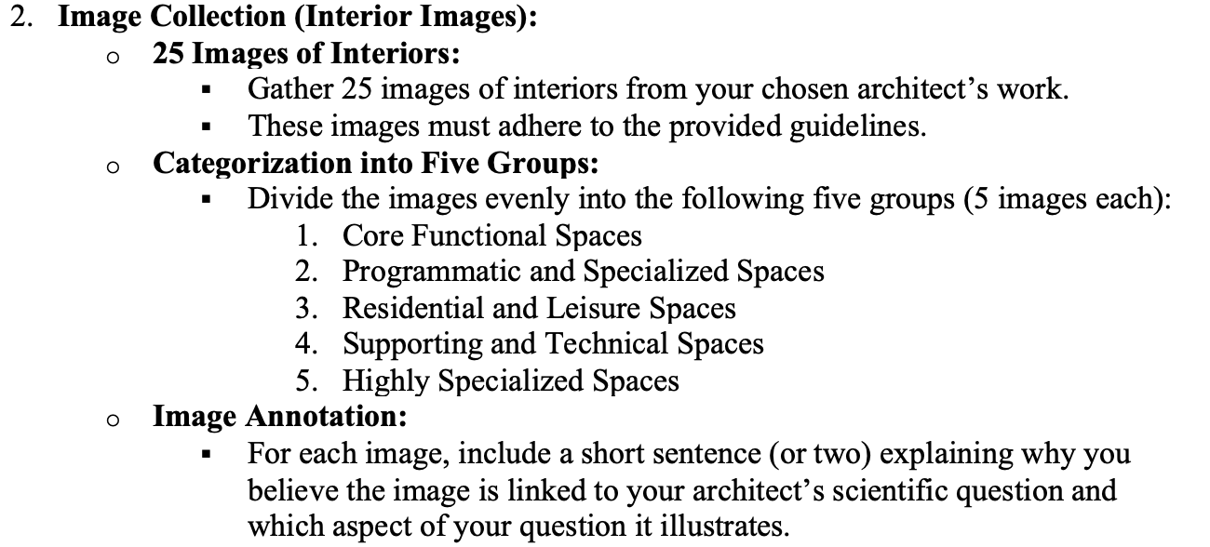

### 

### **How to organize your slides Organization**

* In your slides, add a divider titled **Interiors with sub-dividers for each category**
* Place your 25 collected images appropriately sorted by category and select some for inclusion in your written document as well. Also include the interior category when adding to your doc. For each image you should say a little about what question it addresses and why you think so.

### **3. Collecting Architectural Examples to Test the Hypothesis in a 2 x 2 matrix**

Your final task is to collect **10 additional images** of your architect’s interiors that visually support (or illustrate) why you think they are right about their hypothesis. Your goal here is to show **why** your architect would believe their hypothesis “makes visual sense.” For instance, if your architect is Zaha Hadid, you might select her curvilinear interiors to illustrate a hypothesis such as:

*“Curvy spaces improve social interaction or put people in a better mood.”*

But just finding purely supportive images is not a scientific approach. We also need to see spaces that **contradict** or challenge the hypothesis in order to truly test it. Provide a sentence or two explaining why you think each image fits the cell it is meant to visually make sense of.

**Example of what we mean by this 2 x 2**:

Consider the hypothesis:

*“People prefer curvilinear spaces over rectilinear spaces for social interaction.”*

**What you need to do**

1. **Identify Curvilinear Examples**: Look for actual photos or renderings of spaces with flowing, rounded forms. Assess if the design seems to foster conversation, gathering, or communal activity (e.g., comfortable seating arrangements, pleasant circulation paths). Use your own judgment. We need two examples in each cell.
2. **Identify Rectilinear Examples**: Find spaces with mostly straight lines and right angles (e.g., boxy rooms, grids). Again, evaluate if they appear personally inviting or uninviting for social interaction. We need two examples in each cell.
3. **Place Each Example in the Table**: For every image of a space, decide whether it belongs in “Good for Social Interaction” or “Not Good for Social Interaction,” and whether it is curvilinear or rectilinear. Because the table is so small, place a thumbnail inside the table and include larger images below it, appropriately labelled. There should be 2 images per cell.
4. **Reflect on Any Patterns**: After populating the table, notice if curvilinear spaces tend to appear in the “Good” quadrant or if you can find counterexamples (e.g., a rectilinear space that actually works well).  
     
   This part of the exercise will help you (1) visualize the wide range of possible designs, (2) see where they might fit with respect to the hypothesis, and (3) identify clear cases that either support or contradict the “always prefer curvilinear” claim.
5. Add these images and the 2 x 2 matrix to your Word or Google Doc to show off the meaning of your main question. Be sure to include a sentence or two explaining why it interpets the cell it is meant to illustrate.
6. Issue: for many of you, you have created a question that can be converted into many different scientific hypotheses. You only need to show a 2 x2 for one of the many hypotheses you might have in your question. Ask Chat to extract out the part of the question that interests you most (you have to indicate which part does interest you the most) and to rewrite that in a tighter more scientific manner, as it were a conjecture. State that immediately above your 2 x 2. {We found this in discussion today this issue in the way many of the questions were rewritten.]
7. In your google doc create an Appendix for your ChatGPT prompts.Include your chatgpt prompt as discussed in Appendix 4 below on improving your own prompt.

Deliverable THREE checklist:

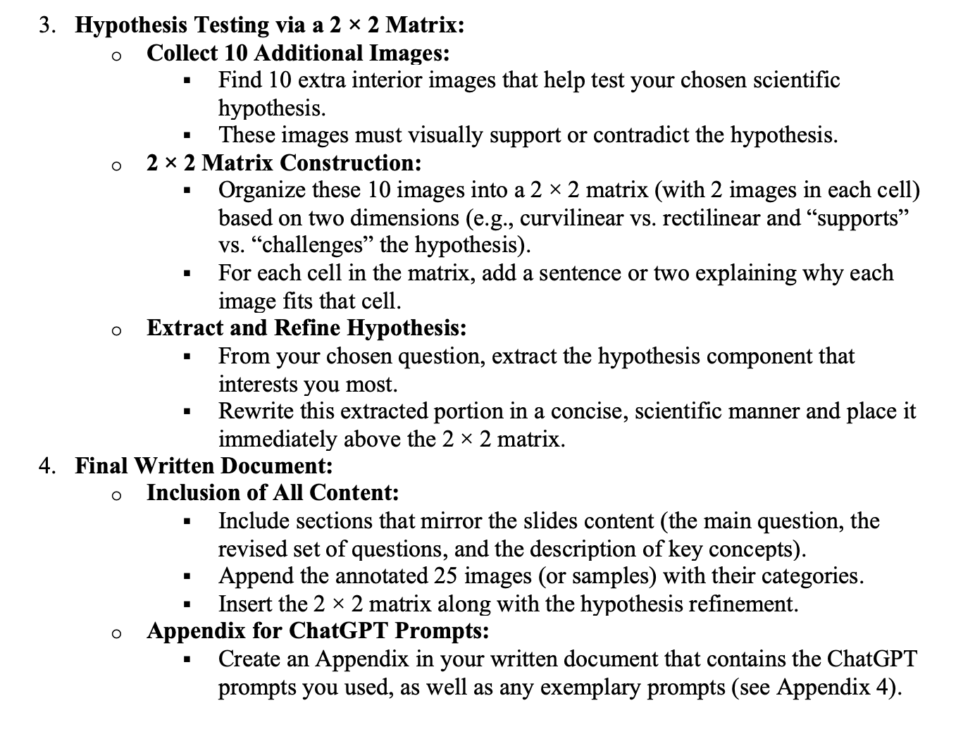

**APPENDICES**

### Appendix 1:

### Types of Interiors, hierarchically organized with sub-categories

### 

### A. Core Functional Spaces

1. Public Spaces (e.g., lobbies, atriums, courtyards)
2. Circulation Spaces (e.g., hallways, elevators, stairwells)
3. Event and Exhibition Spaces (e.g., auditoriums, conference halls)
4. **Programmatic and Specialized Space**s
5. Learning and Knowledge Spaces (e.g., libraries, lecture halls)
6. Workspace Areas (e.g., offices, meeting rooms)
7. Retail and Commercial Spaces (e.g., shops, food courts)
8. Dining and Hospitality Spaces (e.g., restaurants, lounges)
9. Cultural and Recreational Spaces (e.g., museums, theaters)
10. Religious or Ceremonial Spaces (e.g., chapels, worship halls)
11. **Residential and Leisure Spaces**
12. Residential Spaces (e.g., apartments, suites)
13. Wellness and Fitness Spaces (e.g., gyms, spas)
14. **Supporting and Technical Spaces**
15. Technical and Back-of-House Spaces (e.g., mechanical rooms, storage)
16. Transitional and Buffer Zones (e.g., vestibules, waiting areas)
17. Parking and Transportation Spaces (e.g., parking garages, loading docks)
18. **Highly Specialized Spaces**
19. Laboratories
20. Data Centers
21. Greenhouses
22. Studios

### Appendix 2**:**

### **Criteria for Selecting Photos of Architectural Interiors**

***A Framework Focused on Cognitive and Affective Processing***

#### 1. Architectural Feature Relevance

* Specific Attributes:
  + Ensure each photo clearly displays the targeted architectural elements (e.g., garden views, curvilinear walls, visual complexity).
  + The feature should be prominent enough for viewers to recognize and evaluate its potential effects on cognitive processes.
* Spatial Definition:
  + The photo should capture the interior’s spatial layout, highlighting how these targeted features integrate into the overall design.

#### 2. Image Quality and Consistency

* Resolution and Clarity:  
  • High-resolution images are essential to appreciate fine architectural details, which can affect perceptions of visual complexity and depth.
* Lighting and Color Balance:  
  • Adequate and natural lighting helps reveal textures and contours; this is crucial when assessing features like curvilinear forms or the interplay of light and shadow that can influence mood and concentration.
* Consistent Perspective:  
  • To facilitate comparison across images, maintain a relatively consistent perspective or framing that emphasizes the architectural features of interest. This may be difficult if you cannot find many images to choose from.

#### 3. Visual Complexity and Aesthetic Composition

* Balanced Complexity:  
  • Draw on research in environmental psychology suggesting that an intermediate level of complexity is often most stimulating for cognitive processing (Kaplan & Kaplan, 1989).  
  • Photos should neither be overly busy nor too sparse, supporting focused work and creativity.
* Composition and Proportion:  
  • Consider the layout of visual elements (e.g., symmetry vs. asymmetry), as these contribute to aesthetic responses such as awe or calm, potentially impacting stress levels and well-being.

#### 4. Contextual and Environmental Factors

* Integration with Nature:  
  • For photos featuring views of gardens or natural elements, consider how the natural setting is framed.  
  • There is robust evidence indicating that exposure to natural scenes can foster recovery from stress (Ulrich, 1984).
* Functional Context:  
  • Evaluate whether the interior setting supports focused work or creative activities.  
  • For example, spaces designed to stimulate or relax should clearly communicate these functions through their design elements.

#### 5. Cognitive and Neurophysiological Impact

* Emotional and Cognitive Resonance:  
  • Select photos that are likely to evoke measurable responses in terms of concentration, creativity, or stress modulation.  
  • Studies in neuroarchitecture have shown that features like curvilinear lines can influence approach-avoidance behaviors and aesthetic judgments (Vartanian et al., 2013).
* User Engagement:  
  • Consider how the architectural elements interact with human perception.  
  • The image should allow for the assessment of how design elements (e.g., fluid vs. rectilinear forms) might lead to different affective responses, such as eustress or a sense of awe.

#### 6. Documentation and Comparative Utility

* **Metadata and Annotations:**
* **Include clear metadata for each image (e.g., source, date, and context of the photograph) to allow for systematic analysis across the set.**
* Comparative Standardization:  
  • Ensure the selection allows for a systematic comparison across various interior environments so that cognitive processing effects can be reliably associated with specific architectural features.

### References

* Kaplan, S., & Kaplan, R. (1989). *The experience of nature: A psychological perspective*. Cambridge University Press.
* Ulrich, R. S. (1984). View through a window may influence recovery from surgery. *Science, 224*(4647), 420-421.
* Vartanian, O., Navarrete, G., Chatterjee, A., Fich, L. B., Leder, H., Modroño, C., … & Skov, M. (2013). Impact of contour on aesthetic judgments and approach-avoidance decisions in architecture. *Proceedings of the National Academy of Sciences, 110*(Supplement 2), 10446-10453.

## **Appendix 3:**

## **Chatgpt Prompt to improve the questions**

*Instructions:*You are given several versions of a question originally posed by a famous architect to cognitive and neuroscientists. Your task is to consolidate these versions into a single, coherent question written in clear, modern language that resonates with contemporary cognitive and neuroscience researchers. The question may address various cognitive or neural processes (such as spatial memory, emotional regulation, attention, etc.) and different architectural or design features (such as natural elements, spatial layout, color, scale, etc.). Your rewriting should adapt to whatever key features and topics are present in the original versions.

Your output should include two parts:

1. **Rewritten Question:**
   * Develop a single, cohesive version of the question that may span several sentences.
   * Ensure the language is accessible and precise for a modern cognitive/neuroscientific audience.
2. Integrate any relevant features or topics mentioned in the original versions without assuming a specific domain.
3. **Explanation of Key Concepts:**
   * **Cognitive–Neuroscientific Concepts:** Identify and explain any cognitive or neural processes mentioned or implied (e.g., spatial memory formation, emotional regulation, attention, stress responses, etc.).
   * **Architectural/Design Ideas:** Identify and explain any architectural or design features mentioned (e.g., natural elements, spatial layout, visual aesthetics, integration with surroundings, etc.).  
       
     1. Tailor the explanation so that it reflects the specific features in the question.

**Checklist for a Successful Rewritten Question:**

* **Modern and Clear Language:**
  + Is the question written in language that contemporary cognitive and neuroscience researchers will understand?
* **Cohesion:**
  + Does the rewritten question integrate elements from all given versions into one clear inquiry?
* **Adaptability:**
  + Does the question reference the relevant features or topics (cognitive, neural, architectural) present in the original versions, without assuming a fixed domain?
* **Cognitive–Neuroscientific Relevance:**
  + Are any key cognitive or neural processes mentioned or clearly implied in the question?
* **Architectural/Design Relevance:**
  + Are any specific architectural or design features mentioned or clearly implied in the question?
* **Separate Explanation:**
  + Is there a distinct paragraph with bullet points that explain the underlying cognitive–neuroscientific concepts and technical architectural ideas relevant to the question?
* **Clarity and Precision:**
  + Is the content logical, well-organized, and free of ambiguity?

*Example Output Format:*

**Rewritten Question:**[Insert the integrated, modern version of the question here.]

**Key Concepts Explained:**

* **Cognitive/Neural Processes:**• [Explain any relevant cognitive or neural concepts such as spatial memory, emotional regulation, attention, etc.]
* **Architectural/Design Features:**• [Explain any technical architectural ideas present, such as specific design elements, layout considerations, or integration with the environment.]

Emulate the style and nature of the content found in this example answer. You can use it as a template when providing your rewritten questions.   
[Class: then paste in the content starting with

### **Appendix 4:**

**Getting the output you want from LLM's is a hit or miss process. I will often spend 4 hrs working on a prompt. In this case I worked longer and in the end I decided that I was not getting the best answer from Chat on its own or Claude on its own. Both were OK but not as good as I wanted. Claude wanted to give me highly neuro answers and Chat wanted to use non-neuro explanations. So I took both outputs and asked Chat to combine them using this prompt. (Truth: I also had to tinker with Claude's prompt to get it to give me enough of a non neuro answer before askign chat to combine the two.).**

Prompt to Chat: I want you to take these two answers to the same question and create a better answer than each. Do that by keeping every distinct idea and integrating those ideas into a longer version. It should still be easy to read, very clear, good for an ugrad senior and be thoughtful. Do not delete neuro or cognitive points or affect related etc. Just collect them all and present them correctly in the same format as before.

### **Example result [*paste this into your prompt to give Chat a specific exemplar*]**

*Original Question:*

1. **Concise Question**: How does the integration of natural elements in architecture influence spatial memory and emotional regulation?
   * **Expanded Interpretation:** Investigates whether incorporating nature (light, water, vegetation) into design improves cognitive mapping and reduces stress levels.
   * **Deep Explanation:** Wright’s philosophy of organic architecture insists that buildings must harmonize with their natural surroundings. By asking this question, he implies that the deliberate incorporation of natural elements can create environments that support clearer mental mapping and a calming emotional state—principles central to his vision of nature–integrated design.

*Rewritten Question after combining Chat and Claude*

## Example: Your version of Question 1 of Frank Lloyd Wright

[Start pasting from here - ***after you read how good it is***. Not easy to get this level of quality!]

### 1. Rewritten Question

How does the deliberate incorporation of natural elements—such as daylight, water features, and vegetation—within architectural spaces shape human cognitive mapping abilities and emotional regulation processes? Specifically, might Wright’s organic architecture philosophy—which emphasizes harmony between buildings and their natural surroundings—foster more effective spatial memory formation and simultaneously reduce psychological and physiological stress responses? Furthermore, what cognitive, experiential, and neural mechanisms could explain these potential effects and yield sustained benefits for cognitive and affective well-being?

### 2. Explanation of Key Concepts

**a. Cognitive–Affective–Neuroscientific Concepts**

* **Spatial Memory and Cognitive Mapping:** At the cognitive level, we use internal representations (or mental maps) to recall and navigate our surroundings. Natural features like running water or greenery can serve as memorable landmarks that reduce confusion and improve wayfinding. Neural correlates often involve the hippocampus and parahippocampal regions, home to specialized cells (place cells, grid cells) that encode the layout of environments.
* **Emotional Regulation and Stress Reduction:** Exposure to nature within built environments may lower cortisol levels and calm the sympathetic “fight-or-flight” response by boosting parasympathetic activation—sometimes called the “rest-and-digest” system. The amygdala (which processes emotional salience) and the prefrontal cortex (which aids in cognitive control) appear less reactive to stress when environmental stimuli are gentle or restorative, creating conditions for smoother emotional regulation.
* **Biophilia and Well-Being:** Some researchers propose that our evolutionary history fostered a predisposition to seek connections with nature. This biophilic response can activate neural reward pathways, leading to positive affect and potentially aiding recovery from mental fatigue. In practical terms, this means spending time in nature-infused architecture can stabilize mood and enhance cognitive performance over time.

**b. Architectural/Design Ideas**

* **Organic Architecture:** Frank Lloyd Wright’s hallmark approach integrates buildings into their natural environment, using local materials (stone, wood) and design features (e.g., large windows, interior water fixtures) that extend or mirror the surrounding landscape. Rather than superficially placing potted plants, Wright weaves nature into the structural essence of the building.
* **Indoor–Outdoor Continuity:** Strategies like corner windows, extended terraces, and uninterrupted sightlines create a seamless flow between interior and exterior. This expanded sense of space can foster “soft fascination,” capturing attention gently without overwhelming the occupant.
* **Biophilic Design Principles:** Modern adaptations of biophilia emphasize patterns and experiences that evoke natural settings—e.g., using natural analogues in textures and shapes or providing multi-sensory cues (natural light, ambient water sounds). Such choices can reinforce stress reduction and enhance spatial cognition by grounding people in a more restorative, easily navigable environment.

### 3. Situate the Question in Context

Consider visiting the main living room of **Fallingwater**, designed by Frank Lloyd Wright. Sunlight streams in through clerestory windows, while the steady murmur of the waterfall below blends with the surrounding forest sounds. Stone floors mirror the rocky terrain just outside, and glass corners appear to dissolve the boundary between indoors and outdoors. Here, you may find it effortless to form a clear mental map of the space, guided by the constant flow of water and shifting patterns of light. Meanwhile, the calming effect of these natural elements can engage your parasympathetic nervous system—lowering heart rate and cortisol levels—allowing you to experience emotional balance and “soft fascination” as your attention rests on the gentle interplay of architecture and nature.

Google Image Query:  
**Fallingwater interior living room Frank Lloyd Wright**

**[end of example]**

## **FAQ**

1. **Can I use the same building for multiple images/categories?**Absolutely. If one building has distinct interior zones (e.g., a core functional area, a specialized workspace), you can showcase multiple angles or spaces within it. Just be sure each image is relevant to the specific category you’ve placed it in.
2. **How detailed should each version (form) of my main question be?**Provide clear, concise statements of your question. Each version should highlight a different angle or nuance of your hypothesis—e.g., focusing on different user experiences, architectural elements, or measurable outcomes. You should run ChatGPT on each version to see which one you like the best.
3. **What if I can’t find enough interior images for certain categories?**Try searching subcategories (e.g., “Zaha Hadid meeting room interiors” rather than just “Zaha Hadid interior”). If you still struggle, consider whether another building by the same architect might fit that category.
4. **How do I present the 25 interior images and the 10 supportive vs. 5 contextualizing/challenging images?**
   * **In your Slides**: Create labeled dividers for each of the five main categories. Insert the corresponding images beneath each sub-divider.
   * **Hypothesis Testing**: Within a dedicated “Hypothesis Testing” section, clearly distinguish images that support the hypothesis from those that challenge or provide alternative contexts.
5. **What does it mean to “visually interpret” the hypothesis?**Show (via images or a simple table/diagram) what a space that supports the hypothesis looks like compared to one that challenges or contradicts it. For instance, if your hypothesis involves curvilinear forms promoting social interaction, use visuals to illustrate what “promoting interaction” actually means in real-world design terms.
6. **How do I handle contradictory examples?**Contradictory examples are essential for critical thinking. Explain why they might not align with the hypothesis—perhaps the design context, user behavior, or functional requirements differ. Show that your hypothesis isn’t universally applicable or needs refining.
7. **Do I need to include references or citations for the images I collect?**Yes. Even if you’re using online sources or your own photographs, cite them (e.g., website URLs or personal photography notes). This ensures academic honesty and clarity on where you obtained the material.
8. **Is there a specific format for the table of curvilinear vs. rectilinear spaces?**No strict format is required, but be sure your slides make it easy for viewers to see which examples support or challenge the hypothesis. A simple 2×2 table with rows for “Good / Not Good” and columns for “Curvilinear / Rectilinear” works well.
9. **What is a good criteria for deciding on what image to use?**Some images will be just general images of the building, but your images should be specific to showcasing the architect's style and hypothesis. A good way to find those images is to get a specific google query to look up the images.

## **Evaluation Rubric**

| **Criterion** | **Exemplary (5)** | **Good (4)** | **Satisfactory (3)** | **Needs Improvement (2-1)** |
| --- | --- | --- | --- | --- |
| **Clarity of Main Question and other questions not chosen as the main one.** | Clearly presents a thoughtful, well-articulated version of the chosen CNfA question including conceptual explanations of technical terms. Also presents the other questions of the architect in a revised form. | Provides excellent version of main question with conceptual explanations. Other questions are less impressive but overall clarity is good. Or some technical terms are not conceptually explained. | Presents fewer than all the questions in revised form. Or the articulatoin of the chosen question could be better, or there are several technical terms not conceptually explained. . | Fails to present main revised question in an improved manner or misses several of the unchosen quesitons, or they lack clarity; or most technical terms are unexplained. |
| **Quantity & Quality of Interior Images** | Collects all 25 images plus the required 10 supportive and 5 contextual/challenging images; all images are high quality and highly relevant. | Meets or slightly exceeds the required number of images; most are relevant and acceptable quality. | May miss the full count of required images or include some low-quality/repetitive images. | Significantly under the required number of images; many are of low quality or irrelevant to the assignment. |
| **Organization & Slide Presentation** | Slides are professionally organized with clear titles, dividers, and logical flow. The 5 categories are neatly separated. | Slides show general coherence and labeling; the 5 categories are addressed, though transitions may be choppy. | Slides are minimally organized; some categories or divider labels may be unclear. | Disorganized slides that make it difficult to distinguish categories; poor visual presentation overall. |
| **Hypothesis Testing & Interpretation** | Clearly demonstrates how images support vs. challenge the hypothesis; offers insightful reasoning about each example’s place in the 2×2 or table. | Adequately distinguishes supportive vs. challenging examples; some reasoning is present, but could be deeper. | Partially addresses supportive vs. challenging examples but lacks thorough explanation or clarity in classification. | Fails to meaningfully separate supportive from challenging images; no clear analysis of how they test the hypothesis. |
| **Visual Interpretation of the Hypothesis** | Provides a clear visual or diagram/table showing what confirms/contradicts the hypothesis, with strong evidence and explanations. | Includes a visual representation of the hypothesis; mostly clear but may not fully address confirmations vs. contradictions. | Mentions visual confirmation vs. contradiction but does so in a simplistic or unclear way. | No meaningful visual or diagram to differentiate supportive vs. contradicting evidence. |
| **Depth of Analysis & Reflection** | Thoroughly reflects on patterns, noting any limitations or counterexamples; demonstrates a nuanced understanding. | Observes some patterns and acknowledges possible exceptions; shows reasonable depth of analysis. | Offers some observations but lacks deeper insights or misses the significance of contradictory examples. | Little to no analysis of the significance of the findings; mostly descriptive without deeper insight. |
| **Overall Quality & Completeness** | Delivers a polished, coherent set of slides/documents meeting all requirements; strongly demonstrates the assignment’s objectives. | Meets nearly all requirements with minor gaps; presentation is mostly coherent and complete. | Addresses most requirements but may have notable gaps or inconsistencies. | Fails to meet key requirements or lacks coherence in the final submission. |

**Tip:** Your final submission should show thoughtful curation of images and a clear conceptual understanding of how each image relates to your architect’s question and hypothesis. Good luck!

*20% of the grade will be determined by an estimate by the overall quality of the work. That includes thoughtful choice of images, polishing/improving of the output of ChatGPT by iterating on the answer, and formal qualities of the presentation in both doc and slides.*

Output:

# ChatGPT 4o:

### **✅ Evaluation Summary**

#### **1. Clarity of Main Question and Other Questions**

**Score: 5 (Exemplary)**

* The main question is clearly rewritten in an articulate, layered form.
* Additional questions are also rewritten with improved clarity and neuroscientific relevance.
* Key cognitive and architectural terms are explicitly defined in a dedicated section—great use of rubric guidelines.

#### **2. Quantity & Quality of Interior Images**

**Score: 5 (Exemplary)**

* All 25 interior images are present and sorted by the five categories.
* Each image includes relevant architectural context and a brief rationale linking it to the associated question.
* Additional hypothesis-testing images are included in the 2×2 matrix, with both supportive and challenging examples.
* Sources are cited or listed clearly.

#### **3. Organization & Slide Presentation**

**Score: 5 (Exemplary)**

* Slides are neatly divided into the five interior categories, each with labeled images and concise annotations.
* The hypothesis section and explanation of terms are well organized and presented with consistent formatting.

#### **4. Hypothesis Testing & Interpretation**

**Score: 4.5 (Strong-Good)**

* The 2×2 matrix is present with a clearly stated hypothesis.
* There is generally strong reasoning for each quadrant, although a few supporting vs. challenging distinctions could use slightly more elaboration to reinforce the contrast (e.g., "confusing users" vs. "enhancing understanding" could be specified more with environmental details or user function).
* The matrix structure is clearly laid out, and reflection is present.

#### **5. Visual Interpretation of Hypothesis**

**Score: 5 (Exemplary)**

* The hypothesis is visually illustrated using diverse real-world architectural examples.
* Each quadrant in the matrix has image evidence, showing clear examples of what supports vs. challenges the hypothesis.
* Explanations for cell placement are concise and informative.

#### **6. Depth of Analysis & Reflection**

**Score: 4 (Good)**

* There is reflection on the implications of transparency, fluidity, and hierarchy, and how different combinations support or complicate social interaction and spatial cognition.
* Further discussion of contradictory patterns could deepen the analysis (e.g., why some rigid spaces still promote social engagement).

#### **7. Overall Quality & Completeness**

**Score: 5 (Exemplary)**

* The submission demonstrates strong integration of neuroscience and architectural theory.
* Formal qualities (titles, spacing, visual balance) are polished.
* All deliverables are addressed thoroughly.

### **⭐ Final Assessment:**

**Overall Grade Estimate: A / Exemplary** This presentation is an excellent model of interdisciplinary thinking and clear communication. With minor enhancements in depth of reasoning in the 2×2 matrix (especially in interpreting challenges), it could be considered publication-worthy for a CNfA capstone.

# Gemini:

Okay, here's the original evaluation with the score included:

Evaluation Method and Principles

My evaluation is based on the criteria provided in "A2_ Your Chosen Scientific Question + Interiors Rubric.pdf". The principles I'm applying are:

* Clarity and Completeness: How well the student understood and articulated the main question and related concepts.
* Accuracy and Relevance: The quality and relevance of the chosen images and their connection to the research question.
* Organization and Presentation: The structure and clarity of the slides.
* Hypothesis Testing: How effectively the student used the 2x2 matrix to visually represent and analyze the hypothesis.
* Depth of Analysis: The level of insight and critical thinking demonstrated in the analysis.
* Adherence to Instructions: Following the specific guidelines and formatting requirements.

Specific Evaluation

Based on the provided documents, here's a breakdown of the evaluation:

* Clarity of Main Question and Other Questions:  
  + The student provides a "Main Question" and a "Rewritten Question," demonstrating an attempt to refine the original question as instructed.
  + The rewritten question is more detailed and incorporates relevant concepts like "transparency," "spatial fluidity," and "non-hierarchical organization".
  + The student also includes "Additional Questions Rewritten," showing they addressed the requirement to revise the other questions.
  + The "Explanation of Terms" section is present and explains "Cognitive/Neural Processes" and "Architectural/Design Features," which is a key requirement.
  + Evaluation: Overall, this section is well done. The student has clearly attempted to improve upon the initial questions and provided explanations of key terms.
  + Score: 5 (Exemplary)
* Quantity & Quality of Interior Images:  
  + The student has included numerous images organized into the five categories: "Core Functional Spaces," "Programmatic and Specialized Spaces," "Residential and Leisure Spaces," "Supporting and Technical Spaces," and "Highly Specialized Spaces".
  + Each image has a caption explaining its relevance to the main question or one of the other questions.
  + Evaluation: The student seems to have met the requirement for the number of images and provided explanations, demonstrating a good effort in selecting and justifying the images.
  + Score: 4 (Good)
* Organization & Slide Presentation:  
  + The slides are organized with clear titles and dividers, making it easy to follow the content.
  + The layout is generally clean and professional.
  + Evaluation: The organization of the slides is effective.
  + Score: 5 (Exemplary)
* Hypothesis Testing & Interpretation:  
  + The student has included a "Hypothesis Matrix" (the 2x2 matrix) and attempted to categorize images as "Supports hypothesis" or "Challenges hypothesis" based on "Transparency, Spatial Fluidity, non-hierarchical organization" vs. "Opaque, rigid, hierarchical".
  + The explanations for each cell in the matrix vary in quality and depth. Some provide reasonable justifications, while others are a bit vague.
  + Evaluation: The student has correctly created the 2x2 matrix, but the analysis and justification of the images within it could be stronger and more insightful.
  + Score: 3 (Satisfactory)
* Visual Interpretation of the Hypothesis:  
  + The 2x2 matrix itself serves as the visual interpretation, showing the contrasting architectural styles and their perceived effect on the hypothesis.
  + Evaluation: The matrix fulfills this requirement, but as mentioned above, the explanatory text within the matrix could be improved.
  + Score: 4 (Good)
* Depth of Analysis & Reflection:  
  + While there's some analysis within the matrix, a more in-depth reflection on broader patterns, limitations, or counterexamples could enhance this section.
  + Evaluation: This is an area where the student could add more nuance and critical thinking.
  + Score: 3 (Satisfactory)
* Overall Quality & Completeness:  
  + The submission is relatively complete, addressing most of the requirements.
  + The quality is generally good, but there's room for improvement in the depth of analysis and critical thinking, especially in the hypothesis testing section.
  + Evaluation: The student has put together a solid submission that meets most of the criteria.
  + Score: 4 (Good)

Suggestions for Improvement

* Depth of Analysis in Matrix: The student should elaborate more on *why* specific images support or challenge the hypothesis. They should delve into the architectural elements in the images and link them more explicitly to the cognitive and neural processes mentioned in their rewritten question.
* Reflect on Patterns: In the analysis, the student could discuss if there are any trends they observed. For example, do certain types of spaces *consistently* support the hypothesis, or are there contextual factors that influence the results?
* Address Limitations/Counterexamples: Acknowledge any limitations in the analysis (e.g., subjective interpretation of images, lack of empirical evidence). Discussing counterexamples in more detail would also demonstrate critical thinking.
* Polishing: The student should proofread and refine the language in the matrix to ensure clarity and precision.

In conclusion, the student has demonstrated a good understanding of the assignment requirements and produced a reasonably complete submission. With some further refinement in the analysis and reflection, this work could be excellent.

Final Score: 4 (Good)

Justification:

The student demonstrates a strong understanding of the assignment, particularly in the clarity of the questions and the organization of the presentation. The weakest area is the "Hypothesis Testing & Interpretation," where the analysis needs more depth. The overall quality is good, indicating a solid effort and understanding of the core concepts.

# Claude:

# **Evaluation of the Student Response**

I'll evaluate the student's submission based on the rubric criteria provided in the assignment document, focusing on how well they've met the requirements and executed the project.

## **Evaluation Method**

I'm analyzing the PDF titled "annotated-Kazuyo Sejima CNfA Question.pptx.pdf" which appears to be the student's slide presentation. I'll assess this against the rubric provided in "A2_ Your Chosen Scientific Question + Interiors Rubric.pdf" which outlines the specific requirements and scoring criteria.

## **Detailed Assessment by Criterion**

### **1. Clarity of Main Question and Other Questions (4/5)**

* **Strengths**: The student clearly presented Sejima's main CNfA question with a well-articulated rewrite. They also included rewrites of the other four questions as required.
* **Areas for improvement**: While the conceptual explanations of terms are present, they could have been more directly connected to the specific wording in the main question.

### **2. Quantity & Quality of Interior Images (5/5)**

* **Strengths**: The student collected the required 25 images across the five specified categories (5 images per category). The images appear to be high-quality and relevant to Sejima's architectural style.
* **Note**: The 2×2 matrix includes additional images as required for hypothesis testing.

### **3. Organization & Slide Presentation (5/5)**

* **Strengths**: The slides are professionally organized with clear titles and logical flow. The categories are neatly separated (Core Functional Spaces, Programmatic and Specialized Spaces, Residential and Leisure Spaces, Supporting and Technical Spaces, Highly Specialized Spaces).
* **Quality**: The presentation has a clean, consistent design that enhances readability.

### **4. Hypothesis Testing & Interpretation (4/5)**

* **Strengths**: The student created a clear 2×2 matrix showing examples that support vs. challenge the hypothesis.
* **Areas for improvement**: While there is some explanation for why each image supports or challenges the hypothesis, the reasoning could be more thoroughly developed in some cases.

### **5. Visual Interpretation of the Hypothesis (4/5)**

* **Strengths**: The 2×2 matrix effectively visualizes what confirms/contradicts the hypothesis.
* **Areas for improvement**: The annotations could include more specific neurological or cognitive reasoning related to spatial cognition mechanisms mentioned in the hypothesis.

### **6. Depth of Analysis & Reflection (3/5)**

* **Strengths**: The student shows understanding of the relationship between architectural features and cognitive effects.
* **Areas for improvement**: The analysis could go deeper in connecting specific architectural elements to neural mechanisms mentioned in the explanation of terms. Some observations remain somewhat surface-level.

### **7. Overall Quality & Completeness (4/5)**

* **Strengths**: The submission meets all the core requirements of the assignment and shows thoughtful curation of images.
* **Areas for improvement**: A bit more refinement in connecting the cognitive neuroscience concepts to the specific architectural features could elevate the work.

## **Summary Evaluation**

**Total Score: 29/35 (83%) - B**

The student has successfully completed the assignment with particular strengths in organization, image selection, and presentation quality. They've clearly articulated Sejima's CNfA question and demonstrated an understanding of how her architectural principles might influence neural mechanisms.

To improve this submission, the student could:

1. Develop deeper connections between specific architectural features and their neurological implications
2. Provide more detailed reasoning in the hypothesis matrix
3. Further elaborate on how transparency and spatial fluidity specifically affect the neural mechanisms mentioned in their explanation of terms

The student has shown competency in understanding the relationship between cognitive neuroscience and architecture through Sejima's work, but could push their analysis to a more sophisticated level by more explicitly connecting the architectural and neural concepts.